**MCPAA Video Links**

Getting Ready for Recruitment

<https://youtu.be/55BrYetTJns>

[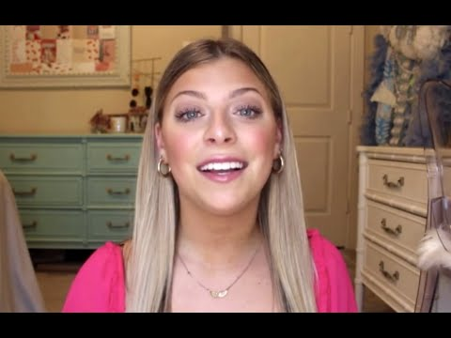](https://www.youtube.com/embed/55BrYetTJns?feature=oembed)

Sample Introductory Video

<https://youtu.be/oGRZUY42mV8>

[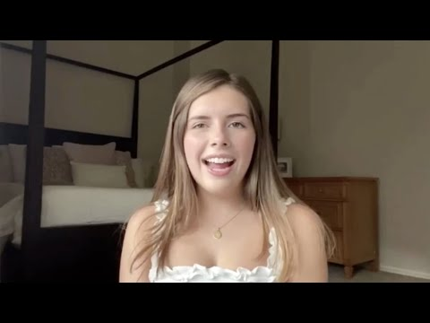](https://www.youtube.com/embed/oGRZUY42mV8?feature=oembed)

Conversation Tips

<https://youtu.be/53i0udyrW2k>

[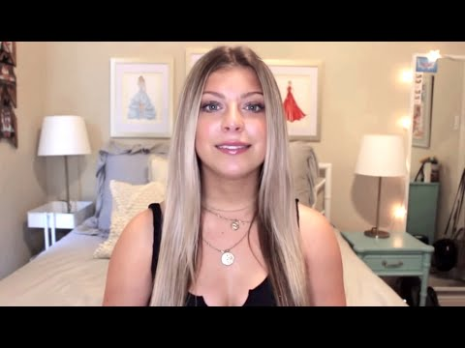](https://www.youtube.com/embed/53i0udyrW2k?feature=oembed)

More Recruitment Tips and Tricks

<https://youtu.be/C1xo3SYnvWo>

[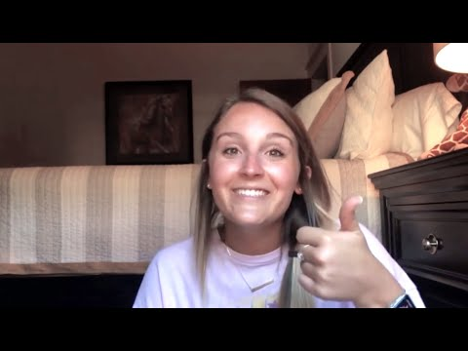](https://www.youtube.com/embed/C1xo3SYnvWo?feature=oembed)

The Biggest Recruiting Question

<https://youtu.be/3Ma_w3w0Hn4>

[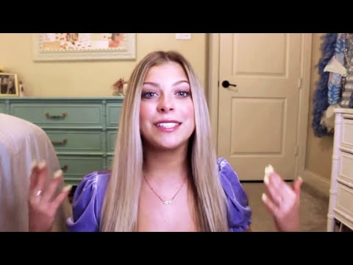](https://www.youtube.com/embed/3Ma_w3w0Hn4?feature=oembed)

**Questions?**

​

All general recruitment questions should go to <mailto:mcpaarecruitment@gmail.com>.